**HW 7**

**251/502**

**Malik**

Given the Temperature dataset for the Month of June

1. Create a heatmap in R
2. Create a “heatmap” in Tableau

Hints * x-axis will be the days of the month (1,2,3…30), y-axis will be the hours (0,1,2…23)

For R, you will need to convert the sampletime to a POSIXct format, then you will need to split the date/time into two separate columns, one for day and one for hour.

For Tableau, you will use the original file and manipulate the date to reflect day and hour. There is no formal heatmap option in Tableau, but there is a workaround.

502:

Please apply this to humidity and wind. In R, I would like for you to venture into exploring scale_fill_viridis and faceting the three plots.

For Tableau, create a dashboard with all three visuals

Also, please aggregate all the values (temp, humidity, wind) to a daily average and bring back the date column to reflect year-month-day and do a quick time plot or snapshot of dataframe.

# R Section

## HeapMaps

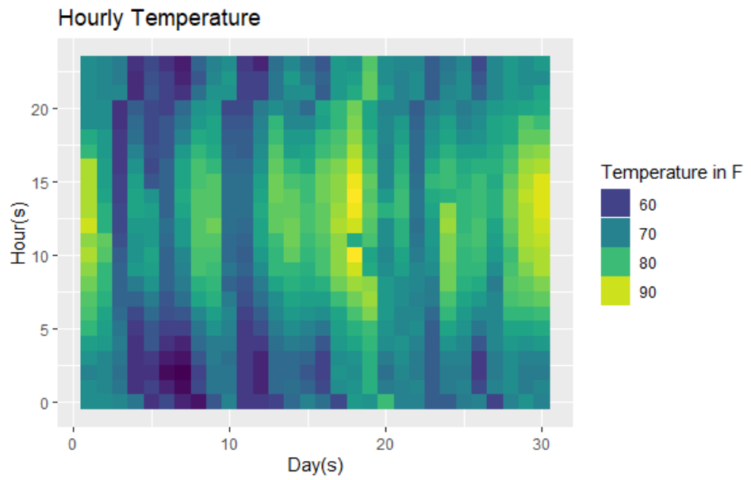

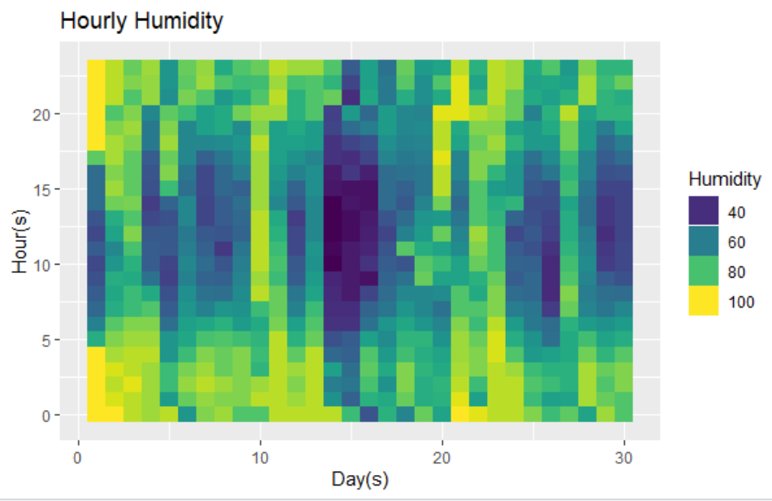

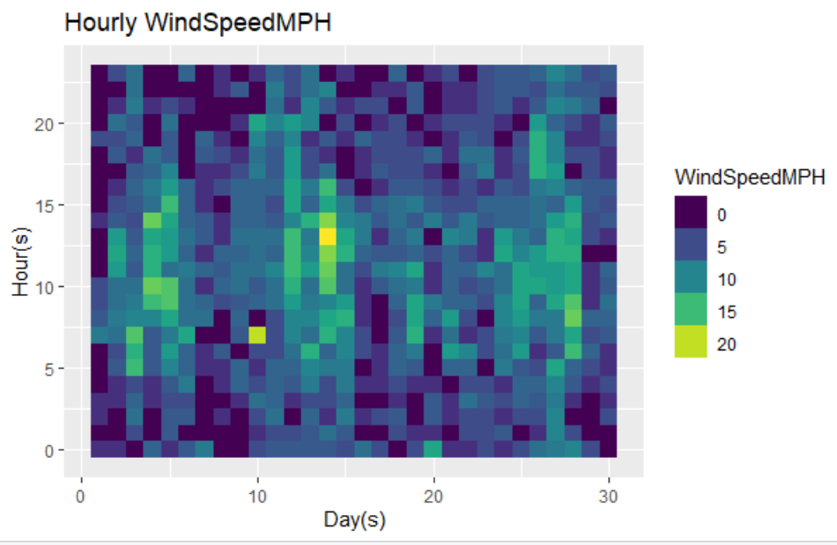

## All 3 together:

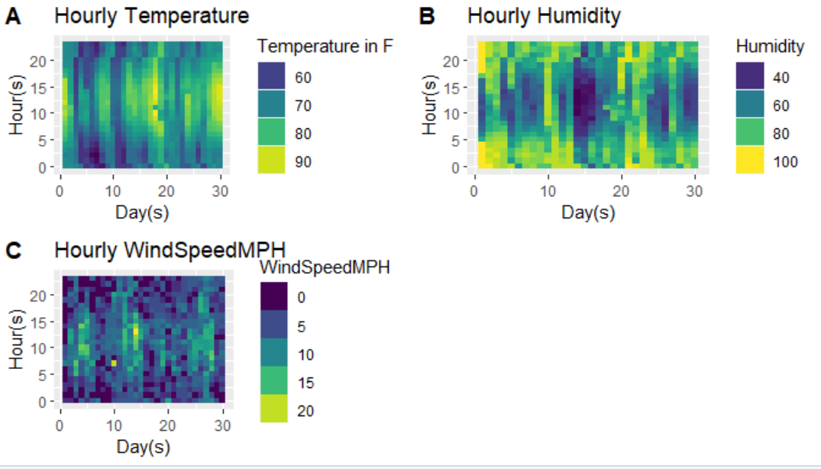

## Facet

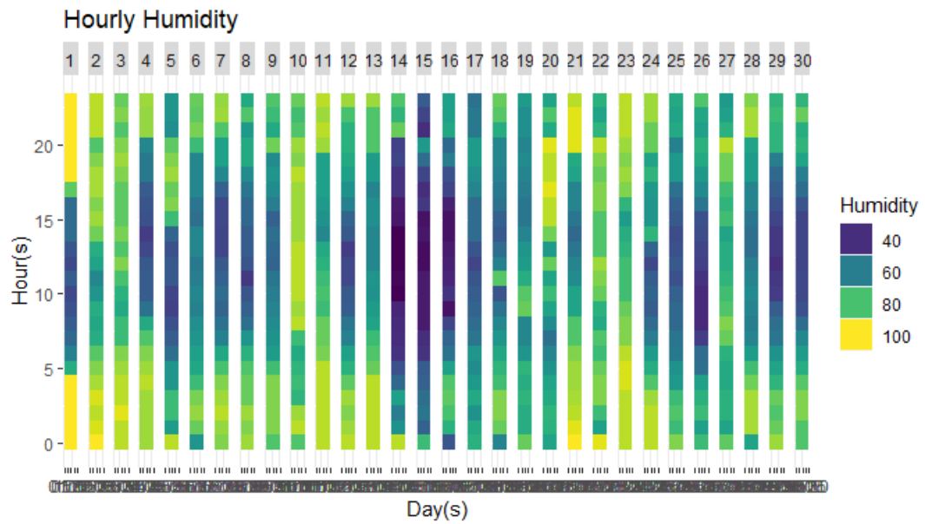

Facet based on days. Did not know else I can use it.

## Aggregate:

I used aggregate function and it did not mess the date/time column. This is my final aggregated df:

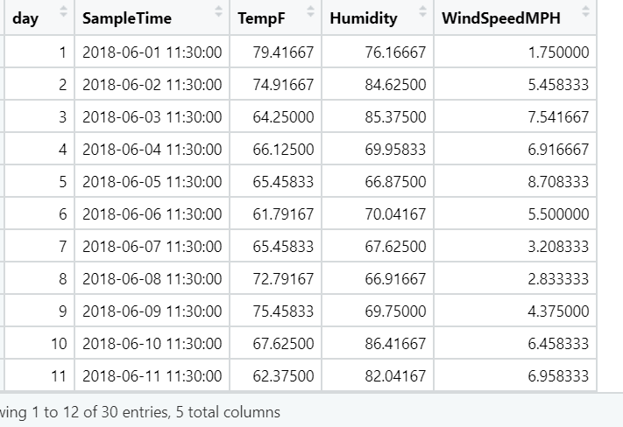

# Tableau Section:

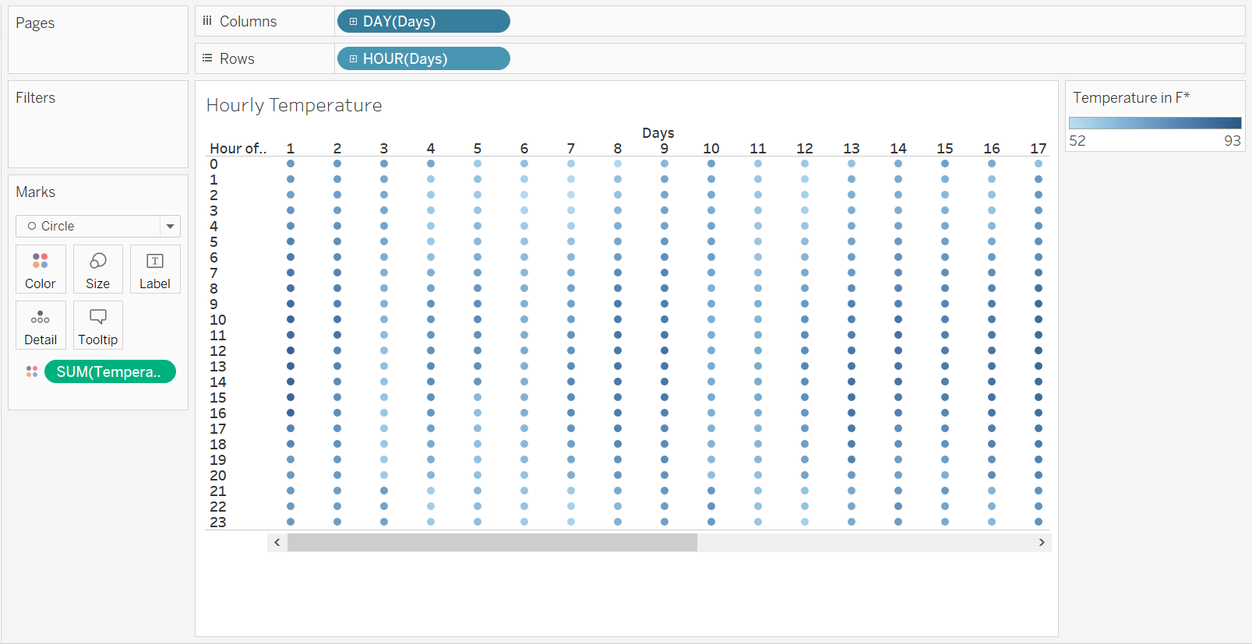

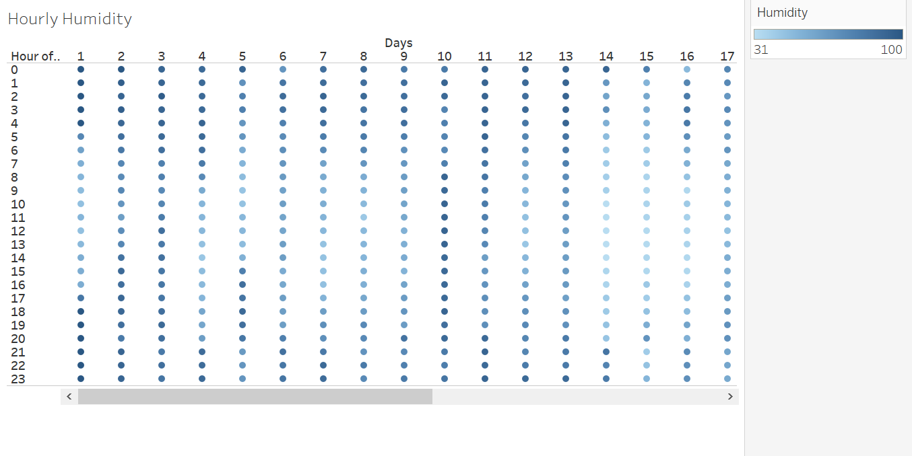

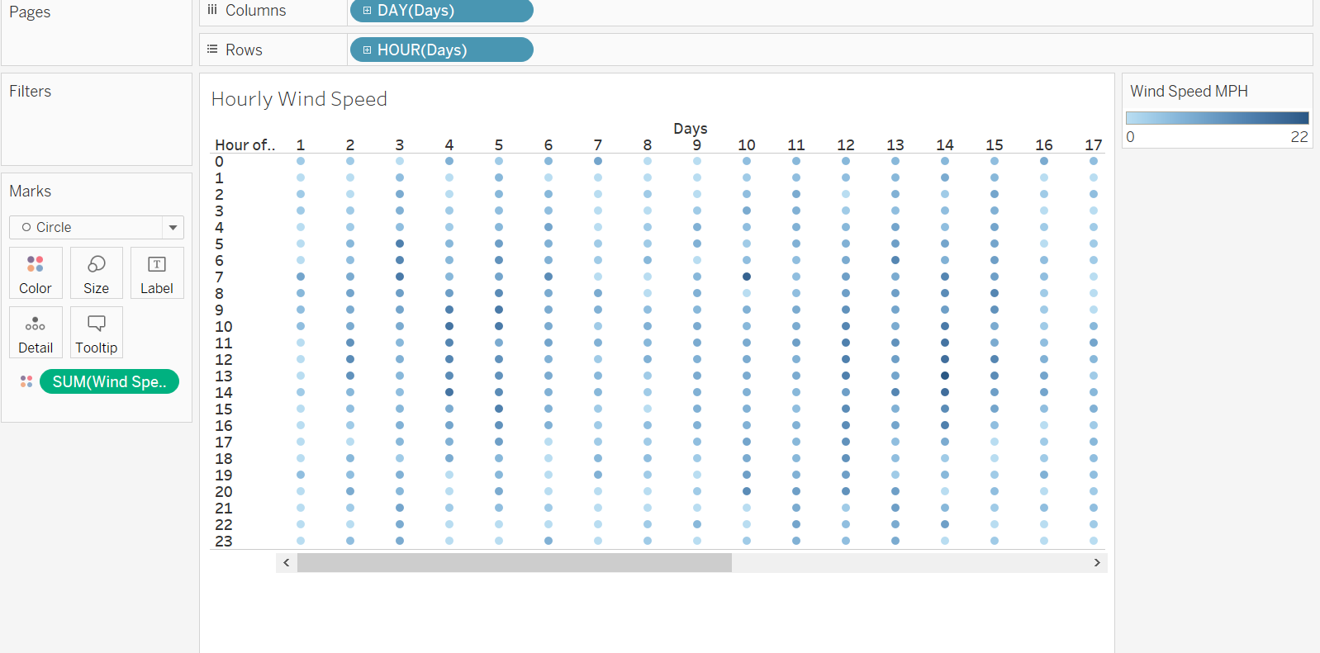

## Dashboard:

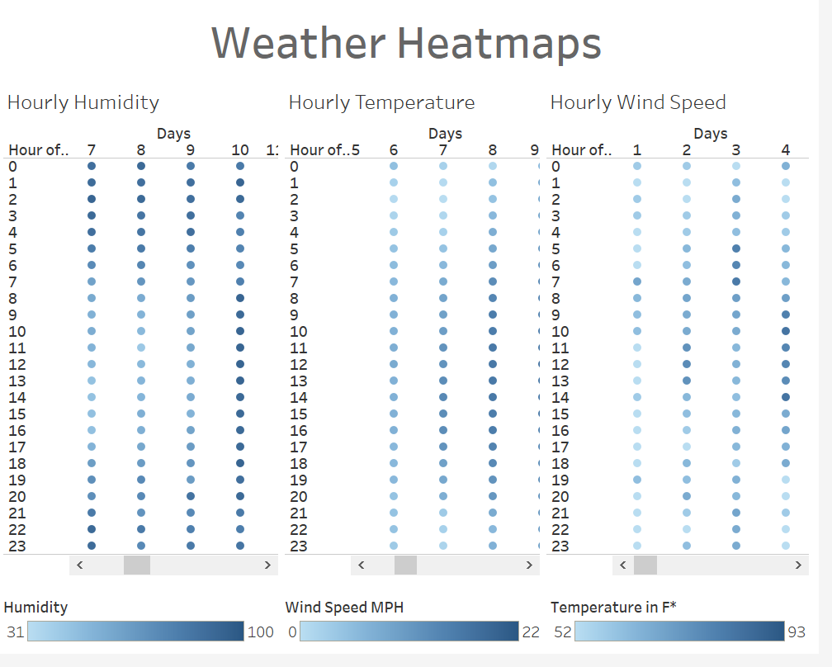

## Code:

library(cowplot)

library(ggplot2)

library(scales)

library(reshape2)

library(xlsx)

library(tibbletime)

library(dplyr)

library(lubridate)

#install.packages("tibbletime")

#install.packages("lubridate")

#############################################################################

data <-read.csv("C:/Users/Malik/Documents/GitHub/Data-Visualization-Data502/Home Works/HW 7/ext_data.csv")

summary(data)

head(data)

# Doing on whole data

data$SampleTime = as.POSIXct( strptime(x = as.character(data$SampleTime), format="%m/%d/%Y %H:%M"))

data$date = data$SampleTime

data = data %>% mutate(year = year(date),

                   month = month(date, label=T),

                   day = day(date),

                   hour =hour(date))

head(data)

#install.packages("viridis")

library(viridis)

?scale_fill_viridis()

#Uses the viridis color scale.

### Plotting heat map

g1 <- ggplot(data, aes(x = day,hour)) +

  geom_tile(aes(fill = TempF)) +

  xlab("Day(s)") + ylab("Hour(s)") +

  ggtitle("Hourly Temperature") +

  guides(fill=guide_legend(title="Temperature in F"))  +

  scale_fill_viridis()

g1

g2 <- ggplot(data, aes(x = day,hour)) +

  geom_tile(aes(fill = Humidity)) +

  xlab("Day(s)") + ylab("Hour(s)") +

  ggtitle("Hourly Humidity") +

  guides(fill=guide_legend(title="Humidity"))  +

  scale_fill_viridis()

g2

g3 <- ggplot(data, aes(x = day,hour)) +

  geom_tile(aes(fill = WindSpeedMPH)) +

  xlab("Day(s)") + ylab("Hour(s)") +

  ggtitle("Hourly WindSpeedMPH") +

  guides(fill=guide_legend(title="WindSpeedMPH"))  +

  scale_fill_viridis()

g3

# all 3 together

plot_grid(g1,g2,g3, labels = "AUTO")

#### Facet ###

g4 <- ggplot(data, aes(x = day,hour)) +

  geom_tile(aes(fill = Humidity)) +

  xlab("Day(s)") + ylab("Hour(s)") +

  ggtitle("Hourly Humidity") +

  guides(fill=guide_legend(title="Humidity"))  +

  scale_fill_viridis()   + facet_grid(.~ day, scales="free_x")

g4

####### Aggregate

# converting  months abbreviations to numbers

data$month = match(data$month,month.abb)

head(data)

agg = aggregate(data,

                by = list(data$day),

                FUN = mean)

head(agg)

agg2 = agg[c("day","SampleTime","TempF","Humidity","WindSpeedMPH")]

End